**COLLEGE OF COMPUTER AND INFORMATION SCIENCES DEPARTMENT OF SOFTWARE ENGINEERING**

**SWE312: Software Requirements Engineering**

**3rd Term 2023**

**Assignment 2**

**STUDENT IDENTIFICATION**:

**Section:** 46438 **Group Number:** 1

**Name**: Nouv Batey AlQahtani **ID**: 442201905

**Name**: Alanoud Omar Alfakhri **ID**: 442200434

**Name**: Najah Khalid AlRowis **ID**: 442201401

**Name**: Aljouri Abduaaziz AlSarami **ID**: 442202991

**Name**: Amal Mousa Aljasaas **ID**:442201829

**Question 1:**

Express the following constraints in OCL.

1. **Invariants**

(a) A researcher must submit one manuscript.

context Researcher inv:

self.manuscript → size() = 1

(b) A research must be assigned one submission.

context Researcher inv:

self.submissior → size() = 1

(c) A paper must have at most 10000 words.

context Paper inv:

self.wordCount <= 10000

(d) Students are not allowed to review any paper.

context Paper inv:

self.referee → not exists(r | r.isStudent = 1)

**Question 2:** Screen Shots of the outputs

A) A screen shot that represent the output for AddBirthday method.

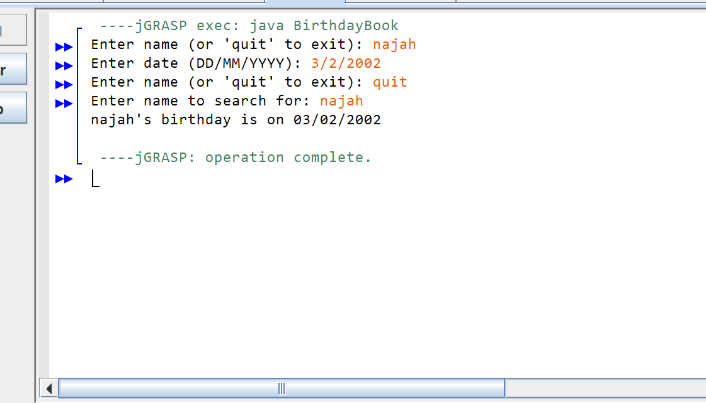

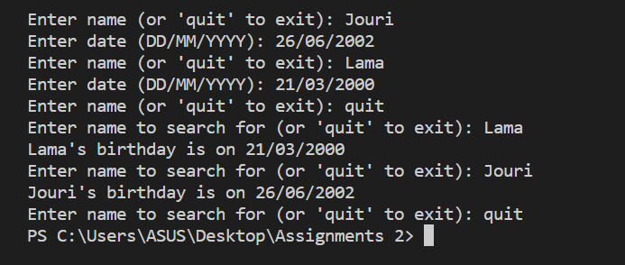B) A screen shot that represent the output for FindBirthday method.

C) A screen shot that represent the output for the **whole** Q2 including method Remind

